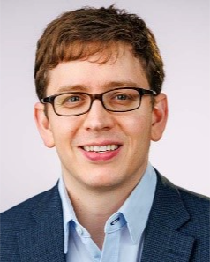 | Aaron Ring, MD, PhD, Associate Professor, Translational Science and Therapeutics Division  Dr. Aaron Ring, who moved from Yale University to Fred Hutch this summer, studies the use of natural "drugs" found within the immune system to treat cancer and reveal new biological insights. One engineered molecule that Ring is working to bring to patients is his first-in-class engineered cytokine therapy. Dubbed “decoy-resistant” IL-18, it’s based on the cytokine interleukin-18, which the human immune system uses to stimulate inflammatory responses. IL-18 acts by binding a receptor on target cells, but also can be easily rendered inactive – or jammed — by a decoy molecule that prevents it from activating its targets. Ring’s “unjammable” form of IL-18 can’t be blocked by the decoy. Decoy-resistant IL-18 can give cancer-fighting immune cells a boost, helping improve their effects in situations where immunotherapies like checkpoint inhibitors won’t work.  Email: aaronring@fredhutch.org

